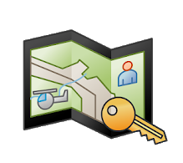
FireMapper Enterprise Quick Reference Guide - Portal
map viewing
Getting access  Access is issued by FireMapper Champions who are listed on https://portal.fireandemergency.nz/projects-and-programmes/firemapper-for-enterprise-project/  - If you have a given portal access logon go to https://portal.firefront.com.au and enter details  - If you have been given a token click on the link or use the QR code which will bring up a screen similar to below.  Easiest access is through FireMapper “Map Viewer”  Other options are available that include live links through google earth and ARC software, plus there are links that allow download of shape files.  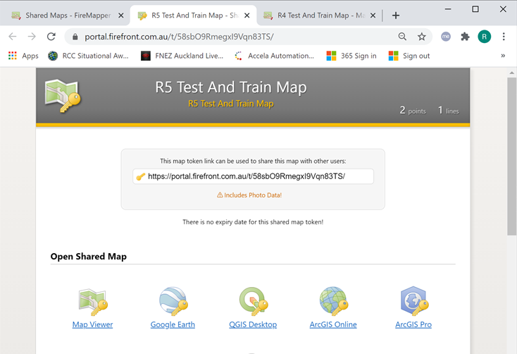 | Main Menu  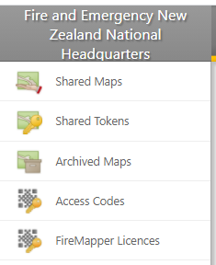  Available current maps  Existing Tokens issued to share incident map  Archived Maps (removed from list on devices)  List of devices accessing our maps  NOT IN USE
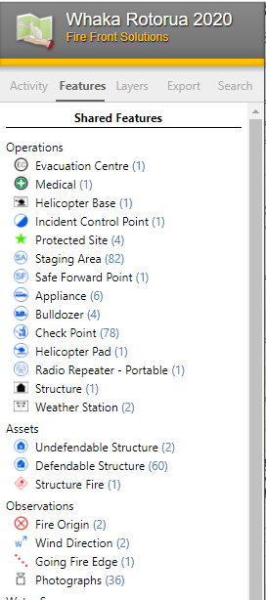  Viewing Shared Maps  Activity – Shows recently added features (incoming intel)  Features - allows feature types to be turned off to manage map clutter on screen and exported maps  Layers – change base layers. Availability of layers will vary as you zoom in and out.  Export – Allows export of printable maps, and various other GIS files that can be used with other software. | Custom map generation  - Go to “Features” and hide features that you don’t want displayed on the exported map.  - Within the “Export” tab select “Open Print Preview”  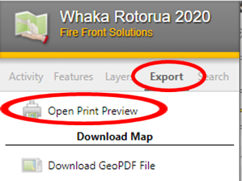  - Edit title and key as required.  - Adjust map size zoom, base layers etc as required.

Some features will be dependent on what access has been given.

