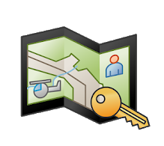
FireMapper Enterprise quick reference guide – Getting started with the mobile app.
For further support: http://docs.firemapper.app/
Download that FireMapper Enterprise from the google or apple app store and open the app.  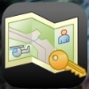  When prompted allow FireMapper to send you notifications, use your location and access the camera.  Enter or scan your FENZ Access Code  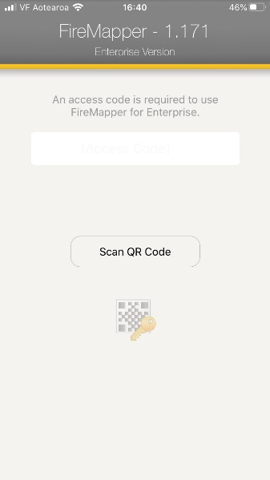  NB; If logged on with a different access code you will need to go “Remove Sharing” by going to “change User Profile” at the bottom of your list of maps. | Enter your details and allow location sharing to help us know keep track of people on the incident ground and where our information is coming from.  Turn on auto sharing If you want all features that you add to the map to be seen by others.  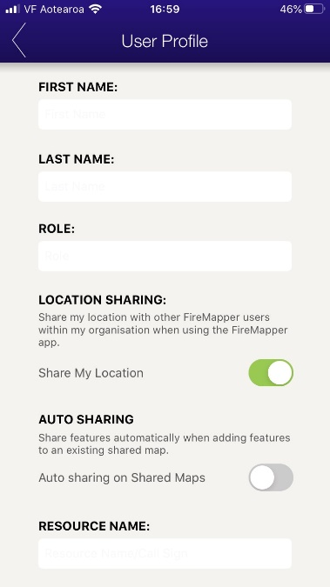  Go to the device settings and ensure that high accuracy location is turned on
Private and shared maps are listed separately. Select from appropriate list as required.  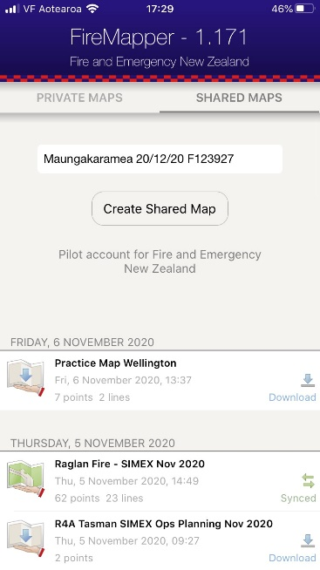 | Using the map  Return to Map Menu  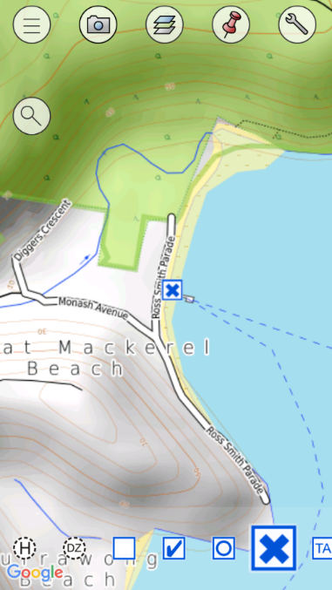  Adjust Map Base Layer  GPS referenced Photos  Map Tools eg. export  Search Location, feature,  coordinates etc.  Mark current location  (with selected icon)

Adding points and line features to the map  1. Scroll through toolbar of and tap on desired feature type. | 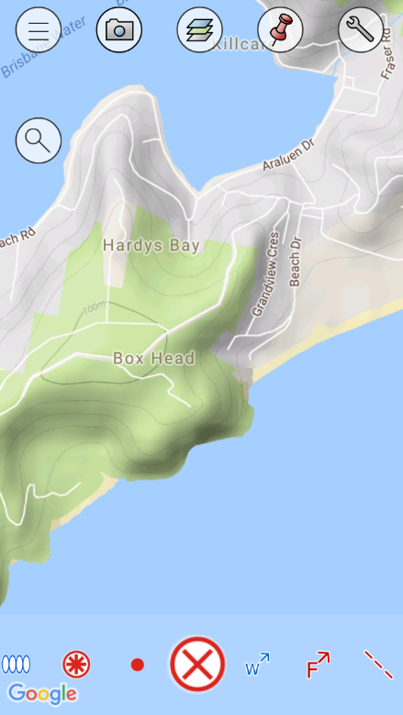  2. Tap and hold your finger on the location you want to add the point or for lines, use your finger to draw the lines.

Feature Key.
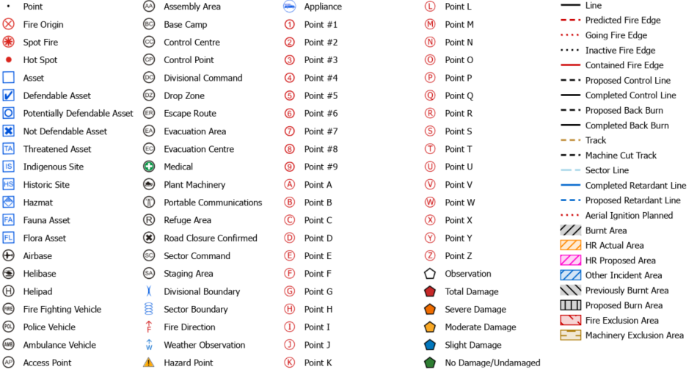

FireMapper Enterprise Quick Reference Guide – Portal map viewing
For further support: http://docs.firemapper.app/
Getting access  - If you have a portal access logon go to https://portal.firefront.com.au and enter details  - If you have been given a token click on the link or use the QR code which will bring up a screen similar to below.  Easiest access is through FireMapper “Map Viewer”  Other options are available that include live links through google earth and ARC software, plus there are links that allow download of shape files.  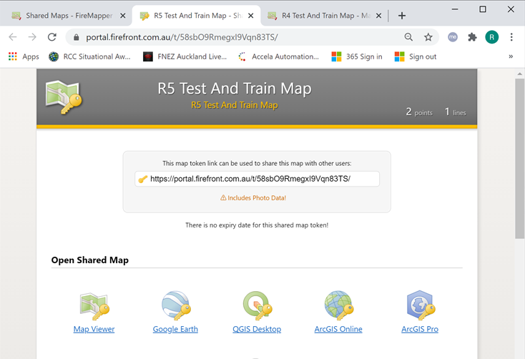 | Main Menu  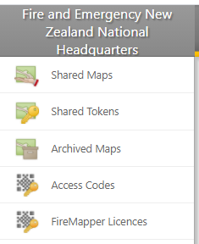  Available current maps  Existing Tokens issued to share incident map  Archived Maps (removed from list on devices)  List of devices accessing our maps  NOT IN USE
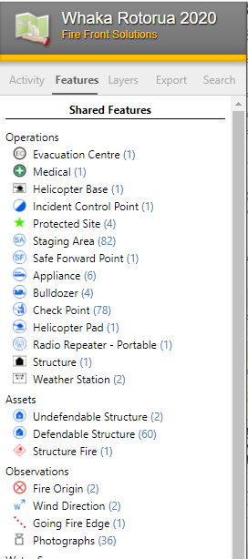  Viewing Shared Maps  Activity – Shows recently added features (incoming intel)  Features - allows feature types to be turned off to manage map clutter on screen and exported maps  Layers – change base layers. Availability of layers will vary as you zoom in and out.  Export – Allows export of printable maps, and various other GIS files that can be used with other software. | Custom map generation  - Go to “Features” and hide features that you don’t want displayed on the exported map.  - Within the “Export” tab select “Open Print Preview”  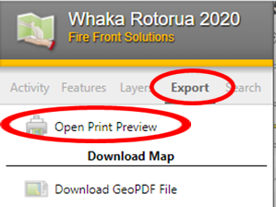  - Edit title and key as required.  - Adjust map size zoom, base layers etc as required.

Some features will be dependent on what access has been given.
FireMapper – Controlling access Quick Reference Guide (Administrators only)
For further support: http://docs.firemapper.app/

Token access | Personnel and temporary Licences
Portal access | Security considerations

Some features will be dependent on what access has been given.

FireMapper Enterprise – importing and exporting data Quick reference guide.

Exporting data | Importing data

Some features will be dependent on what access has been given.

